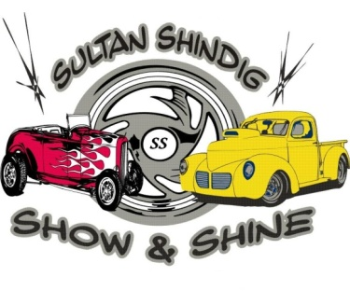
Name:

Address:
City: St Zip
Phone: Email:
Year: Make: Model:

Class Letter (see list below): (class definitions on reverse)

Sunday Show Classes (9:00am – 3:00pm)

A - Muscle Car
B – Modern Muscle
C- Sports Car
D- Street Rod
E-Hot Rod
F-Rat Rod
G-Stock Car
H-Stock Truck
I-Custom Car
J-Custom Truck
K-Most Unique
L-Big Rig
M-Under Construction

We’ll also be judging: Best Flames Best Engine Compartment Best Interior

We will be presenting 1st and 2nd Place Awards Plus a People’s Choice and Best Overall

Fees:
(Events are held rain or shine – No Refunds!)

Pre-Registration: (before 7/7/2024) Late Registration & Day of Show:
Show Entry Fee: $20 Show Entry Fee: $25

Liability Waiver: I, the undersigned, hereby fully release and agree to hold harmless and indemnify The Sky Valley Chamber of Commerce, The City of Sultan, its subsidiaries, agents, volunteers, sponsors, staff, employees, members, successors or assigns of any kind from any and all claims and/or liabilities for loss, damage, injury, or liability that may occur during my participation in this event. Additionally, I do hereby grant permission that any photos and/or video taken of the event by the Sky Valley Chamber of Commerce can be used for promotional purposes.

Signature: (Required) Date:

Please make checks payable to the Sky Valley Chamber of Commerce and send to:
Sultan Shindig Car Show
Mail to: Sky Valley Chamber, PO Box 46, Sultan, WA 98294

Car Show Class Definitions

Muscle Car: Partially Defined by Timeless Rides.com
At its most widely accepted definition the term refers to American, 2-door, rear wheel drive, mid-size model cars, with powerful V8 engines, generally produced between 1964 and 1973. Most muscle cars were current mid-size models being produced by car manufacturers, but with a V8 engine, special trim, and usually better handling and performance options like suspension, braking, etc. Muscle cars are distinct from two-seat sports cars and expensive 2+2 GTs intended for high-speed touring and road racing.

Modern Muscle Car: Same as above but 1974 and newer.

Street Rod: Defined by NSRA (National Streetrod Association)
An automobile of 1948 or earlier which has undergone some type of modernization, to include any of the following; engine, transmission, interior refinements, and any other modifications the builder desires. A street rod is to be driven to events under its own power and is to be used as a safe, non-racing vehicle for total family enjoyment.

Hot Rod: Defined by NSRA (National Streetrod Association)
Same as a Street Rod but 1949 and newer.

Rat Rod: Defined by Streetrods-online.com
A Rat Rod is a newly developed name for the original hot rod style of the early 1950's. A Rat Rod is usually a vehicle that has had many of its non-critical parts removed. They are usually finished in primer or paints that are often period correct, and are very often a conglomeration of parts and pieces of different makes, models and aftermarket parts.

Sports Car: Defined by Merriam-Webster
A low, small, usually 2-passenger automobile designed for quick response, easy maneuverability, and high-speed driving.

Custom: Defined by Merriam-Webster
Any car or truck that has been built, fitted, or altered according to individual specifications and preferences.

Stock: Defined by Corvette/Chevy Expo & OCA National Car Show
Any car or truck that is completely original or restored from the ground up to factory specs including engine, paint, and interior. Items that are wear dated & have been replaced such as tires, shocks, mufflers & battery do not exclude an entry from this class. All other items that have been replaced due to wear are permissible so long as the items replaced are as close as possible to the original.

